LEASE AGREEMENT
This Lease Agreement is made and executed at Gurgaon, on 19th March of 2019 between Mrs. Induja Mathur W/o Tarun Mathur and Mr. Tarun Mathur S/o Late shri A. K. Mathur R/o C-1/09, Sf, Platinum Floor, Ardee City, Sector-52, Gurugram, Haryana (hereinafter called Lessor (which expression shall include his/her heirs, administrators, executors assignees) of the “FIRST PARTY”.
AND
Mr. Sagara Sharma S/o Gopal Sharma R/o h. no. 17, Birkuchi, Near Hindi school, Narangi, No. 2 Bonda, karamrup Metro, Assam-781026 (Aadhar card no. 2452 7971 1500) and Ms. Geeta Jalsi W/o Mr. Sagara Sharma (Aadhar card no. 5854 3794 4175) (hereinafter called the Lessee (which expression shall include the lessee which expression shall include their successors, executors, administrators and assignees) of the “SECOND PARTY”.

WHEREAS the Lessor is the owner of the premises house space bearing the distinct No. 901, 9th Floor , having covered area of 2300 sq.ft. in the Residential complex named Flat no. 901, Regal Tower, Mapkso Royal Ville, Sector-82, Gurugram, Haryana (hereinafter called the LEASED PREMISES or Said Property) Whereas the LESSOR has agreed to let out the said property to the LESSEE and the LESSEE has agreed to take the said property on lease rent

NOW THIS DEED WITNESSETH AS FOLLOWS-:
- That possession of said property will be given to the LESSEE by LESSOR and the tenancy shall commence w.e.f. 1st September 2020 and shall remain for a period of 11 months i.e. up to 30th July 2021. The Lease Agreement can be extended or renewed at the end of this lease period with the increase of 10% by mutual consent on Or Above as per Market value which ever is higher.
- That the LESSEE shall pay a monthly Lease rent of Rs. 14,000 /- (Fourteen Thousand Only) per month in advance on or before 7th day of every English Calendar month. The LESSEE will pay all the additional payments i.e. monthly maintenance, electricity, and club charges etc. as per the prevalent charges by the society rules on a regular basis. In case the monthly maintenance cost up as RWA decide, then total monthly amount will get increased to that extent and lessee shall be liable to pay and pay accordingly.
- That the LESSEE has paid of Rs.21,000 /- (Twenty-one Thousand Only) as interest free security deposit which is refundable, after the completion of the Lease Period, after deduction of dues, if any. This will not be adjusted in last/any month’s lease rent and shall be refunded to second party after inspection of vacated flat and after completion of the Lease Period. If the lessee vacates the property within 01 months, security will be forfeited.
- The Lessee shall pay post dated cheq. in advance with regard to rent of Eleven (11) months or RTGS to the Lessor.
- That there is lock in period of 01 (One) MONTHS of tenancy. In case the there is any breach of any the covenants by the Lessee herein contained, then the lease stands terminated.
- The Lessee agrees to pay Rs.21,000 /- (Twenty-one Thousand Only) towards interest free security deposit at the time of signing the present lease. The Lessor agrees to refund the said amount at the time of vacating of the said Premises. The Lessor however retains the right to make any such deductions from the said security deposit towards unpaid bills, brakeage or repair of the Premises, which does not form a part of normal wear and tear of the Premises, including the lists of fixtures with cost as given in annexure –I at the end of this agreement.
- The Lessee shall pay the concerned authorities directly the bills received for the electricity (power and light), water charges and any other charges in respect of the supply of water and electricity on the basis of actual consumption as per the meter reading.
- The Lessee shall keep all the fittings and fixtures in perfect working condition to the satisfaction of the Lessor.
- The Lessor shall have the option to terminate the lease at any time during its tenure by giving one month’s notice in writing in this regard to the Lessee. During the period covered by the said notice, the Lessee shall allow the Lessor to show the house to the prospective Lessees at all reasonable time.
- The Lessee also shall have the option to terminate the lease at any time during its tenure by giving one month’s notice in writing or pay one month rent in advance in this regard to the Lessor. During the period covered by the said notice, the Lessee shall allow the Lessor to show the house to the prospective Lessees at all reasonable time. The Lessee however agrees that in case the lease of said Premises is terminated by him before the expiry of one month from the date of the signing of the said lease.
- The Lessee shall permit the Lessor, his representatives, servants and agents to enter the demised Premises at all reasonable hours and to inspect the condition or leave notice of all the repairs to be made.
- The Lessee agrees not to sublet the said Premises or any part thereof and use the Premises only for residential purpose only for himself and his family members and not keep any paying guests or shared accommodation with outsiders.
- The Lessee shall not use the Premises for advertising and commercial purpose in any manner in whatever form.
- On the expiration or earlier determination of the lease the Lessee undertakes to yield and deliver peaceful vacant possession of the Premises in its entirety together with all improvements, if any done thereto without any claim for compensation on that account.
- All keys belonging to the said premises are handed over to the LESSEE at the time of signing of the Lease Agreement which the LESSEE shall return to the LESSOR on the expiry or the termination of the Lease Agreement. Any loss of key is subjected to deduction from security amount @ New lock Cost.
- While handover of the flat, their will be a deduction of Rs. 2000/- (Plus Taxes) or as per actual for deep cleaning of the flat. In case the amount for the deep cleaning is low, the same will be returned back.
- RFID card is also issued for car parking and should be returned at the time of termination of rent agreement. In case of loss or damage of RIFD card, INR 1000/- is subjected to be deduction from security amount.
- In case of any delay vacating the flat then addition to rent 1000/- per day will pay able by the lessee.
- The Lessee shall not make any structural alterations or additions to the Premises on any part thereof without the consent of the Lessor first being obtained in writing.
- The Lessee shall be liable to pay for any breakage/ damage to sanitary, electrical goods and fitting appended hereto during the tenancy period caused by the negligence of the Lessee, however reasonable wear and tear caused by efflux of time are accepted. The Lessee further under takes at all times during the term of the lease to keep and maintain the Premises clean, tidy and in good conditions, reasonable wear and tear accepted.
- In the event of breach of any of the conditions and covenants to the observed by the Lessee, the lease may at the option of the Lessor be determined and in such event the Lessor shall be entitled to re-enter and repossess the Premises without prejudice to his rights to recover all arrears and any damages for breach of such conditions or covenants
- On the earlier determination or expiry of lease in the event of the Lessee failing to deliver back the possession within the stipulated time to the Lessor, the Lessee shall be liable to pay per month, twice the amount of rent the previous month. It is hereby expressly agreed and declared by the parties hereto that payment of twice the amount rent paid the previous month will not in any manner or under any circumstance be taken to imply to the renewal of the lease or the enhancement of the lease period.
- The Lessor covenants that the Premises have been whitewashed and repaired at the time of possession. All day to day repairs to the premises shall be undertaken by the Lessee at his own costs. However, the Lessor undertakes that in case of any major repairs such as in electricity, leakage or bursting of sanitary pipes or any damage to the structure occurs; the same shall be attended to by the Lessor alone.
- The LESSOR shall not be responsible for any theft, loss, damage or destruction of any property of the LESSEE or the occupant living in the said premises not for any bodily injury to any person living in the said premises during the occupancy of the leased premises from any cause whatsoever.
- That all payments described in this Deed of the Lease shall become due as from the date here above stated. Under no circumstances shall LESSEE occupy the premises until such payments have been made.
- That the rules, regulations and bye-laws of the Municipal Committee or any other local authority having jurisdiction over the Premises sh1all complied with by the Lessee.
- Any dispute arising over the said Premises shall be subject to the jurisdiction of courts of Gurgaon
Signed at GURGAON, HARYANA.
Dated:-
Lessor Lessee
In witness where of the Lessor and the Lessee have here unto subscribed their hands on this day, month and year written above.
Witnesses:
- Lessor / First Party

- Lessee / Second Party

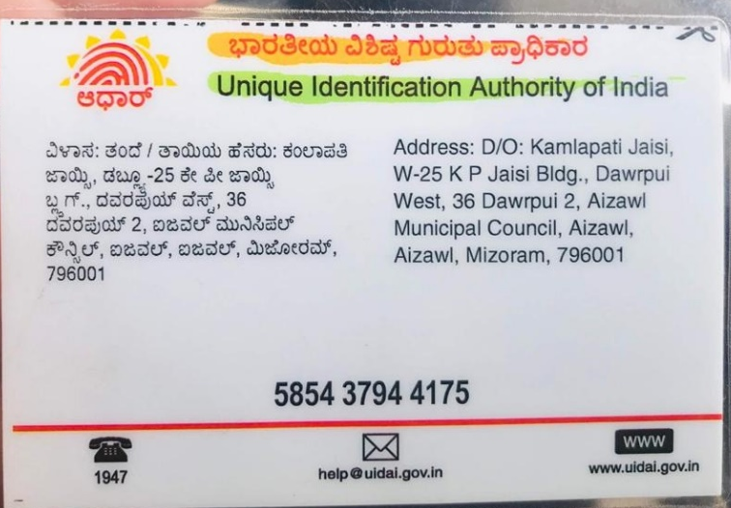
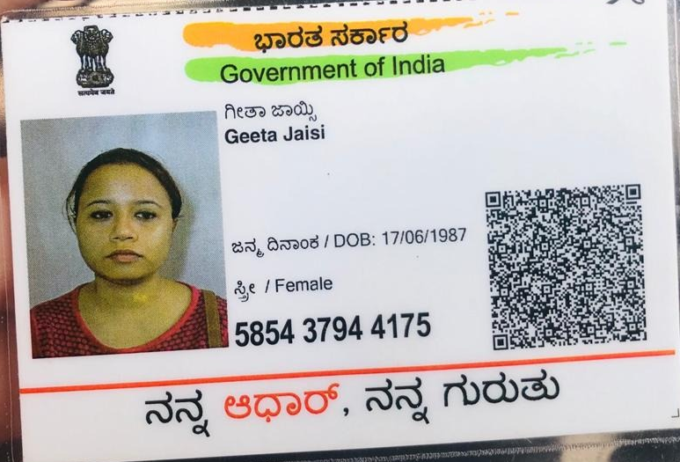

Annexure-I

List of Fittings and Fixtures at Flat no. 901, Regal Tower, Mapkso Royal Ville, Sector-82, Gurugram, Haryana

 | Items | No. of items
1 | Keys- Main door | 2 sets
2 | Keys- Other doors | 1set
3 | Keys- Iron safety door | 2set
4 | Mirrors in Bathrooms | 3
5 | Electricity Meter | 1
6 | Kitchen Cabinets | Complete
7 | Wooden Almirah in rooms | 3
8 | Curtain rods (bedroom 3 and 2 drawing room, TV room 1)
9 | ELICA 60 CM CHIMNY KITCHEN, B07 JQSNZ9N+ exhaust pipe | 1
10 | FAN HAVELLS,1200 mm Havells Enticer | 3
11 | FAN, 1200 mm, Winpro brown Bed room and TV room | 4
12 | Fancy light (All room) | 8
13 | Ventillation Fan 6" Polar ( in bathroom) | 3
14 | Ding don bell | 1
15 | Led Battan Strak light, Plus 10 Watt Halonix | 6
16 | Pride Plus LED 20 watt 6K Havells | 5
17 | Trim Clip Led Panel light 18 Watt Havells | 4
18 | Balcony Cealing light | 4
19 | Kitchen with Modular fittings | 1
20 | Wooden Almira in bedroom | 3
21 | Fixtures in all Bathroom | 4
22 | Locks on Main door | 2
23 | Switches in all rooms (Modular) | 1
24 | Gas Pipeline in kitchen | 1
25 | Mirror in master bedroom | 1
26 | Keys – Almirah in three bed rooms and draws | 3+3 (draws)

Lessor Lessee

